Biosphere Study Guide Name___________________________
1) For each of the following, place an A for abiotic and B for biotic on the lines next to the word.
_____ wind _____sunlight _____ grass _____ bacteria
_____ giraffe _____ soil _____ trees _____ water

2) a. What are the two factors that the Koeppen classification system is based off of?
b. A climate is very humid all year round. Which of the five types of classifications best describes this climate?
c. A climate experiences seasonal temperature changes. Which of the five types of classifications best describes this climate?
3) Explain how a scientist observing a lion stalk a zebra in the tall grasses of the savannas of Africa is a representation of ecology.

4) Match the following descriptions with the appropriate biome.
_____ 50% of Earth’s species found here _____ contains permafrost
_____ animals fur color may change with seasonal changes _____ tree releases chemicals when eaten
_____ animals are bright in color, indicating poisonous _____ plants can become dehydrated and survive
_____ trees found only near water sources _____ moderate climate with seasonal changes
_____ dark color of plants designed to absorb Sun’s energy _____ animals have fatty tissues to store nutrients
_____ animals hibernate or migrate _____ animals have very thick layers of fur

a. taiga b. deciduous forest c. desert d. tundra e. rainforest f. savanna g. grasslands

5) Seven giraffes, four zebras, and three gazelles drink from a watering hole as a hyena lies in wait to attack beneath the grass of the savanna. Several of the giraffes are eating leaves off of a nearby acacia tree.
a. What organisms make up the community in this scenario?
b. How many populations are found in this scenario?
c. Describe 3 ways in which organisms are interacting with each other and/or abiotic factors in this ecosystem.

6) Match the following descriptions with the appropriate vocabulary word.
_____ only eats autotrophs _____ only eats meat _____ produces its own energy
_____eats autotrophs and heterotrophs _____ only eats plants _____eats to receive energy
_____ eats remains of dead animals _____ eats plants and animals _____ only eats heterotrophs
_____ breaks down remains into molecules _____ lion _____ deer

a. heterotroph b. omnivore c. carnivore d. autotroph e. herbivore f. scavenger g. decomposer

7) List some possible limiting factors of a population.

8) If the birth rate is ____________ than the death rate, the population will ____________.

9) Honeysuckle has overtaken the fence of a garden. The honeysuckle is an example of what type of threat to biodiversity?
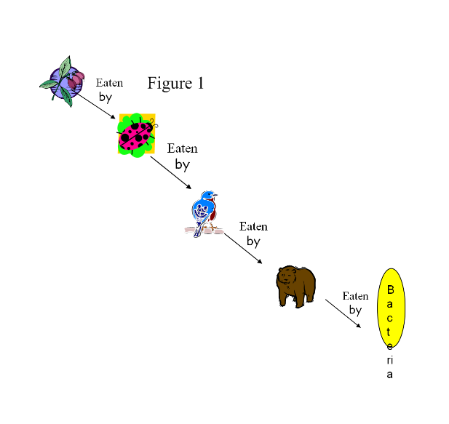
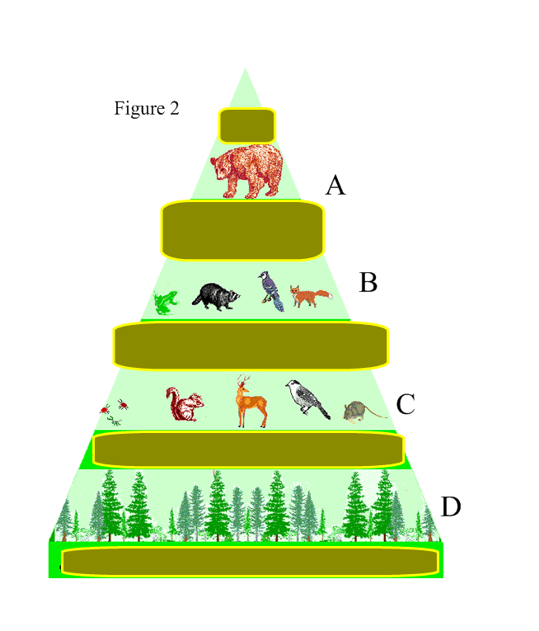
10) Use Figure 1 to answer the following questions.
a. What organism will have the most direct energy from consuming the bird?
b. What organisms will contain some measure of energy from the plant?
c. What organisms will not contain energy from the bird in the food chain?
Use Figure 2 to answer the following questions.
d. What trophic level (indicated by the letters) has the highest level of energy?
e. What trophic level would be labeled as the first trophic level?
f. What trophic level contains tertiary consumers?
g. What trophic level contains producers?

11) What effects would deforestation have on both autotrophs and heterotrophs?

12) ____________ occurs when fertilizer and animal waste runoff are carried into hydrosphere. This process creates _____________ blooms. Eventually, the algae will die, removing _____________ from the water, forming ___________.
13) How does acid rain develop and what are its effects?

14) A pack of wolves has been separated from its natural habitat. It can no longer hunt the prey it usually hunts. What might happen to the wolf population if a new source of prey is not found?

15) Describe what biodiversity is and why it is important to any ecosystem.

16) What are some possible consequences of loss of biodiversity and how can we prevent loss of biodiversity from occurring?

